AI Navigator Business Requirements
Contents
Document Status 2
Outstanding 2
History 2
Purpose 3
Scope 3
User Intake Questions 3
Test for Introduction Screen 3
Question 1: Immediate Need State 4
Question 2: Readiness Level 4
Question 3: Clarity Level 5
Current Coaching Styles 5
Routing Logic 5
Logic Requirements 5
Routing Logic Table 6
AI Coach Recommendation Results Screen Requirements 7
Coach Cards 7
Functional Requirements 8
Analytics Requirements 8

Document Status

Outstanding
- Development to review

History
- AI Navigator Business Requirements (ES+VS+ES draft) 2-Jun-2026
  - Eric updated the requirements based on yesterday’s amazing demo.
  - Added text for intro screen to the requirements
  - Added Willian's screens as design guidance
  - Added the “AI Coach Recommendation Results Screen Requirements”
- AI Navigator Business Requirements (ES+VS+ES draft) 24-Feb-2026
  - Added a column to now recommend two coaches based on Mood, Readiness and Clarity
- AI Navigator Business Requirements (ES draft) 19-Feb-2026
  - Based on varsha’s spreadsheet

Purpose
Design and implement an AI Navigator that asks three questions to route a user to the most appropriate AI Coaching Style based on:
- Immediate need state
- Behavioral readiness
- Cognitive clarity
The AI Navigator must:
- Capture structured user intent.
- Map responses deterministically to one or two recommended coaching styles.
- Pass structured psychometric insights to the receiving AI Coach.

Scope
In Scope
- Three-question intake interface
- Tagging logic
- Deterministic routing engine
- Coaching style mapping
- Psychometric context object
- Coach handoff protocol
- Logging for analytics and calibration
Out of Scope
- Personality assessment
- Clinical diagnosis

User Intake Questions

Test for Introduction Screen
Headline: Find the AI Coach That Fits You
Subheading: Answer 3 quick questions and we’ll match you with the AI coach best suited to your needs right now.
Bullet points:
✓ Quick and easy to answer
✓ Personalized to your needs right now
✓ Helps you start with the right AI coach
Call to action button text: Match Me with an AI Coach

Question 1: Immediate Need State
Prompt: What would feel most helpful to you right now?
Options (single select):
Display Text | Tag
A place to talk openly without being judged | OpenToTalk
Help figuring out my next step | Guidance
A confidence boost | NeedConfidence
To feel understood | FeelUnderstood

Design Guidance
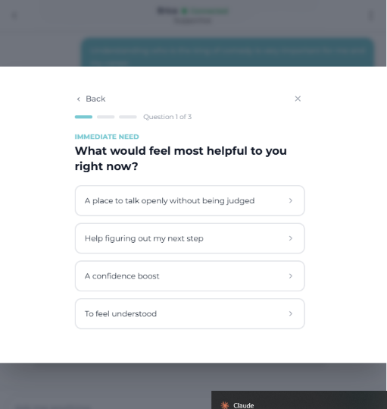

Question 2: Readiness Level
Prompt: Where are you at with this right now?
Display Text | Tag
I’m ready to take action | ReadyToAct
I think it through | ThinkItThrough
I’m not ready to take action yet | NotReadyYet

Design Guidance
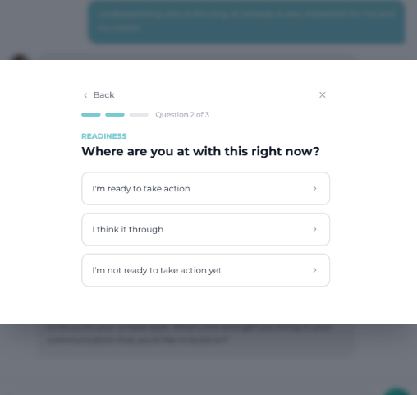

Question 3: Clarity Level
Prompt: How clear are you about what’s going on in your life right now?
Display Text | Tag
I’m clear about what’s going on | Clear
I mostly understand it, but need to think it through | MostlyClear
I’m pretty confused and need help sorting it out | Confused

Design Guidance
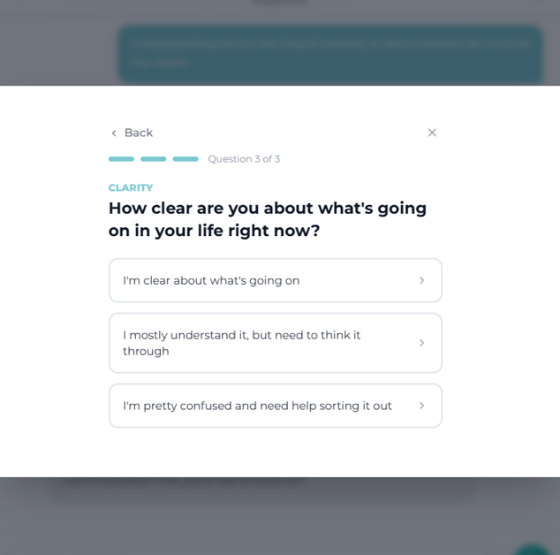

Current Coaching Styles
Coaching Style | Description
Directive | Decisive leadership; Clear direction; Momentum; Action focus; Execution clarity
Discovery | Thoughtful questioning; Assumption testing; Deep thinking; User-generated insight
Empowering | Builds confidence; Highlights strengths; Reinforces ownership; Supports informed choice
Exploratory | Encourages curiosity; Pattern awareness; Meaning-making; Insight before action
Guidance | Promotes autonomy; Establishes boundaries; Encourages learning through experience; User ownership
Nurturing | Emotional presence; Deep empathy; Trust-building; Psychological safety
Strengths | Identifies strengths; Applies strengths strategically; Positive realism; Motivational framing
Supportive | Emotional validation; Grounding; Steady reassurance; Stabilizing progress

Routing Logic
Routing must be determined based on the 36-combination matrix provided.

Logic Requirements
- All 36 combinations must be mapped to one defined Coaching Style.
- Mapping must be table-driven (not hard-coded conditionals).
- If ambiguity arises in future iterations, system may recommend 2 adjacent styles.
- Mapping must be auditable and version controlled.

Routing Logic Table
Mood Tag | Readiness Tag | Clarity Tag | Primary (Personalized) | Autonomy Option
OpenToTalk | ReadyToAct | Clear | Empowering | Exploratory
OpenToTalk | ReadyToAct | MostlyClear | Exploratory | Empowering
OpenToTalk | ReadyToAct | Confused | Discovery | Directive
OpenToTalk | ThinkItThrough | Clear | Exploratory | Empowering
OpenToTalk | ThinkItThrough | MostlyClear | Discovery | Directive
OpenToTalk | ThinkItThrough | Confused | Exploratory | Empowering
OpenToTalk | NotReadyYet | Clear | Supportive | Empowering
OpenToTalk | NotReadyYet | MostlyClear | Nurturing | Strengths
OpenToTalk | NotReadyYet | Confused | Supportive | Empowering
Guidance | ReadyToAct | Clear | Directive | Exploratory
Guidance | ReadyToAct | MostlyClear | Guidance | Directive
Guidance | ReadyToAct | Confused | Guidance | Directive
Guidance | ThinkItThrough | Clear | Guidance | Directive
Guidance | ThinkItThrough | MostlyClear | Guidance | Directive
Guidance | ThinkItThrough | Confused | Exploratory | Empowering
Guidance | NotReadyYet | Clear | Supportive | Empowering
Guidance | NotReadyYet | MostlyClear | Nurturing | Strengths
Guidance | NotReadyYet | Confused | Nurturing | Strengths
NeedConfidence | ReadyToAct | Clear | Empowering | Exploratory
NeedConfidence | ReadyToAct | MostlyClear | Empowering | Exploratory
NeedConfidence | ReadyToAct | Confused | Strengths | Empowering
NeedConfidence | ThinkItThrough | Clear | Strengths | Empowering
NeedConfidence | ThinkItThrough | MostlyClear | Strengths | Empowering
NeedConfidence | ThinkItThrough | Confused | Exploratory | Directive
NeedConfidence | NotReadyYet | Clear | Strengths | Empowering
NeedConfidence | NotReadyYet | MostlyClear | Nurturing | Strengths
NeedConfidence | NotReadyYet | Confused | Supportive | Empowering
FeelUnderstood | ReadyToAct | Clear | Strengths | Empowering
FeelUnderstood | ReadyToAct | MostlyClear | Nurturing | Strengths
FeelUnderstood | ReadyToAct | Confused | Supportive | Empowering
FeelUnderstood | ThinkItThrough | Clear | Nurturing | Strengths
FeelUnderstood | ThinkItThrough | MostlyClear | Nurturing | Strengths
FeelUnderstood | ThinkItThrough | Confused | Supportive | Empowering
FeelUnderstood | NotReadyYet | Clear | Nurturing | Strengths
FeelUnderstood | NotReadyYet | MostlyClear | Nurturing | Strengths
FeelUnderstood | NotReadyYet | Confused | Supportive | Empowering

AI Coach Recommendation Results Screen Requirements

Coach Cards
When coaches are suggested they appear in a coaching card which should show:
- Coach’s name
- Coach’s coaching style
- A short benefit statement for each coach
- A clear call-to-action button: Connect

Top Recommendation Section
The results screen must display one primary AI coach recommendation based on the user’s answers to the three routing questions.
This section should be visually prioritized above all other coach options and should clearly indicate that this is the best recommended starting point for the user.
The section must include:
Headline: We Found Your AI Coach
Subhead: Meet [Coach Name] (e.g., Meet Michael)
Sentence: Based on your answers, we recommend [coach name] because [his/her] [coaching style} coaching style fits what you need right now. (e.g., Based on your answers, we recommend Michael because his empowering coaching style fits what you need right now.)
After this text the coach’s card will be displayed.
The purpose of this section is to give the user confidence that their answers were used to identify a relevant AI coach and to encourage them to begin interacting with that coach.

Other Great Fits Section
The results screen must display two additional AI coach’s cards will be displayed as recommendations under the headline Other Great Fits.
These coaches should be selected based on the user’s answers and should represent strong alternative options if the user does not want to start with the top recommendation.
The two coaches in this section should feel like positive, relevant alternatives, not secondary or inferior options. The design and wording should communicate that these coaches may also be well suited to the user’s needs.

Explore All AI Coaches Section
The results screen must provide access to all available AI coaches under the headline Explore All AI Coaches. The coach’s cards will be display after the headline.
This section should allow users to browse the full set of AI coaches if they prefer to make their own selection or want to review additional options beyond the recommended matches.
If the user already has an active session with a coach, the button should say Resume instead of Connect
The purpose of this section is to preserve user choice while still encouraging the user to start with a recommended coach. It should feel exploratory, flexible, and easy to use.

Functional Requirements
The AI Navigator shall:
- Require the user to answer all three questions before routing.
- Store structured tags.
- Compute style using the routing logic table.
- Generate a user-facing explanation. For example: “Based on what you’ve shared, it sounds like you’re ready to act and would benefit from exploring your thinking a bit more deeply. I’m connecting you with a coach who uses an Exploratory coaching style.”
- Route the user to the recommended AI Coach
- Pass the Psychometric Insights Tag to the user’s profile for the AI Coach to use

Analytics Requirements
The AI Navigator shall log:
- 3 question completion rates
- Tags selected by user
- Coaching style recommended
AI Coaches shall prompt for and log:
- Satisfaction score
- Engagement duration

